Telecom Customer Churn Prediction Assessment

By Aparajita Mukherjee

Table of Content

Project Objective 3

Details of the Project 3

Required Packages 4

Basic EDA(Exploratory Data Analysis) 5

Importing the Data 5

Removing Irrelevant/Nominal Variables 5

Checking the Trend 5

Enrich the Dataset 5

Visualisation 6

Clustering & Interpretation 8

Model Building & Interpretation 10

CART Model 10

Split the Data(70-30) 10

Build the Model 10

Prune the Tree 12

Apply the Model 13

Build Random Forest model 13

Split the Data(70-30) 13

Build the Model 14

Tune the RF Model – 15

Build the Refined RF Model 16

Apply the Model 17

Model Performance Check 18

Confusion Matrix 18

Error Rate 19

Accuracy 19

ROC Curve 20

KS 21

AUC 22

GINI 22

Concordance 23

Conclusion 24

Source of Data 24

# Project Objective

The Objective of this project is to –

1. Showcase the results using graphs and a complete EDA of the given data.
2. Apply appropriate clustering on the data and interpreting the output.
3. Build appropriate models. Interpret the model output.
4. Check the performance of all the models using the model performance measures and validate the output on the unseen dataset. Comment on the best performing model.

# Details of the Project

A total of 15 variables were used for market segmentation in the context of product service management.

|  |  |
| --- | --- |
| ID | Customer ID |
| Age | Customer's age in years |
| Experience | Years of professional experience |
| Income | Annual income of the customer ($000) |
| ZIPCode | Home Address ZIP code. |
| Family | Family size of the customer |
| CCAvg | Avg. spending on credit cards per month ($000) |
| Education | Education Level. 1: Undergrad; 2: Graduate; 3: Advanced/Professional |
| Mortgage | Value of house mortgage if any. ($000) |
| Personal Loan | Did this customer accept the personal loan offered in the last campaign? |
| Securities Account | Does the customer have a securities account with the bank? |
| CD Account | Does the customer have a certificate of deposit (CD) account with the bank? |
| Online | Does the customer use internet banking facilities? |
| CreditCard | Does the customer use a credit card issued by the bank? |

# Required Packages

|  |  |
| --- | --- |
| Library | Significance |
| caTools | building the training and test dataset |
| psych | to get a description of the variables |
| DataExplorer | for Exploratory Data Analysis |
| corrplot | visualising the correlation between variables |
| Hmisc | imputing missing values, advanced table making, variable clustering |
| caTools | helps split the data into train and test |
| NbClust | to create clusters |
| factoextra | visualisation of clusters |
| randomForest | to build Random Forest |
| rpart | to build CART tree and setting the control parameter |
| rpart.plot | to plot the CART tree |
| ggplot2 | to plot the data, also to activate caret package |
| caret | to build CART model |
| randomForest | to build Random Forest |
| partykit | to activate CHAID package |
| inum | to activate CHAID package |
| CHAID | to build CHAID model |
| ROCR | calculate AUC, KS, and other statistics |
| ineq | calculate Gini Index |
| InformationValue | to build Information nValue |

# Basic EDA(Exploratory Data Analysis)

## Importing the Data

getwd()

setwd("C:/Users/HP/Documents/R Dataset")

TheraBank <- read.csv("GL_Thera_Bank_Personal_Loan_Modelling.csv", header = T)

names(TheraBank)

## Removing Irrelevant/Nominal Variables

TheraBank <- TheraBank[,-1]

names(TheraBank)

## Checking the Trend

summary(TheraBank)

str(TheraBank)

dim(TheraBank)

describe(TheraBank)

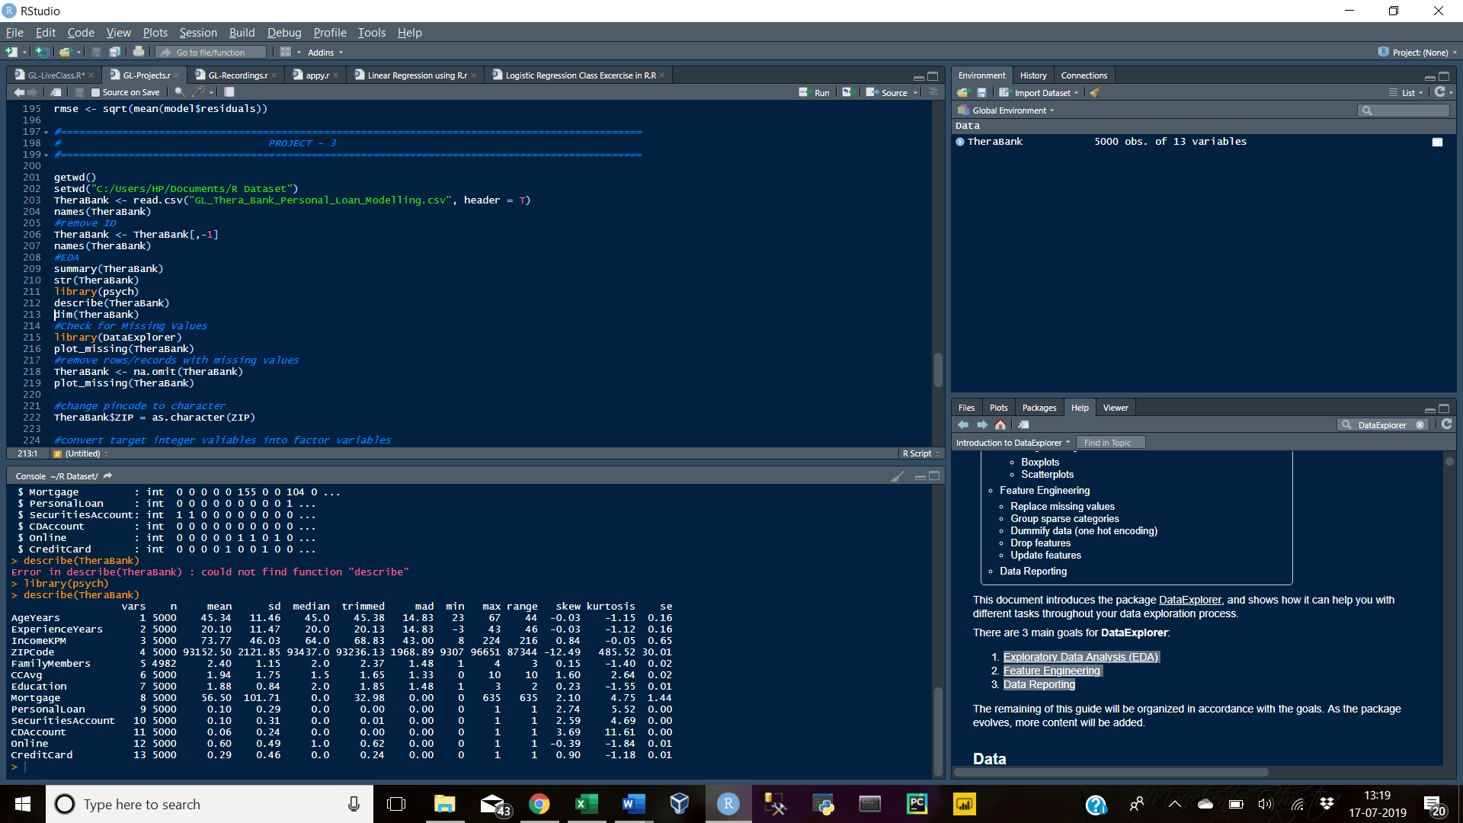

## Enrich the Dataset

#change ZIPCode into categorical variable

TheraBank$ZIP = as.character(ZIPCode)

#convert target variable into factor

TheraBank$PersonalLoan = ifelse(TheraBank$PersonalLoan==1,1,0)

TheraBank$PersonalLoan = as.factor(TheraBank$PersonalLoan)

str(TheraBank)

View(TheraBank)

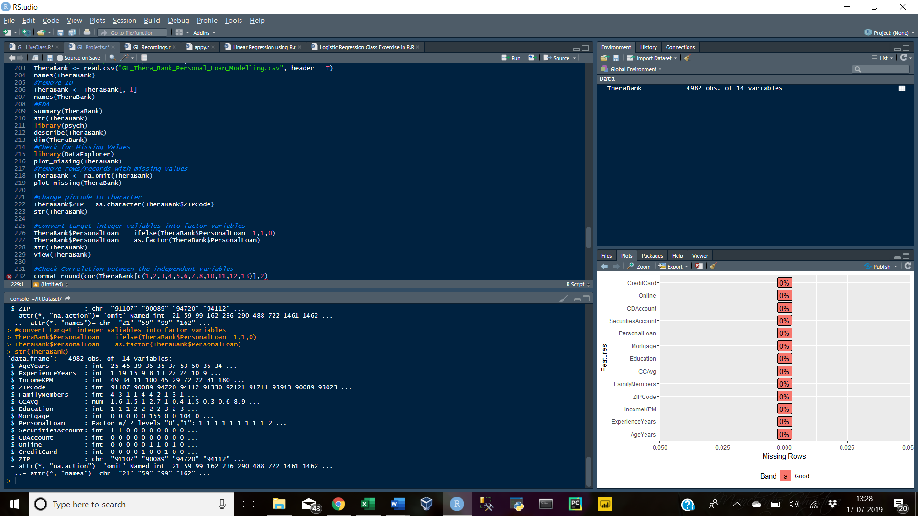

## Visualisation

Check for Missing Values

library(DataExplorer)

plot_missing(TheraBank)

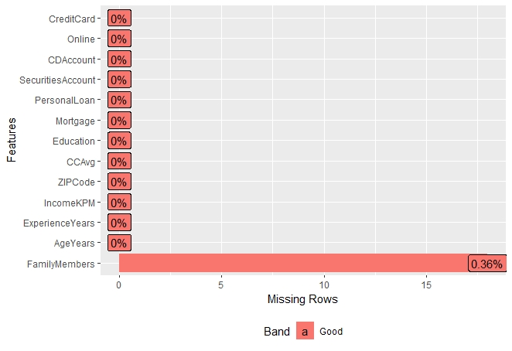

The variable – FamilyMembers in the dataset has 0.36% missing values, which is very low. Therefore, we will remove the observations with the missing values instead of replacing them with the mean.

Remove Missing Values

TheraBank <- na.omit(TheraBank)

plot_missing(TheraBank)

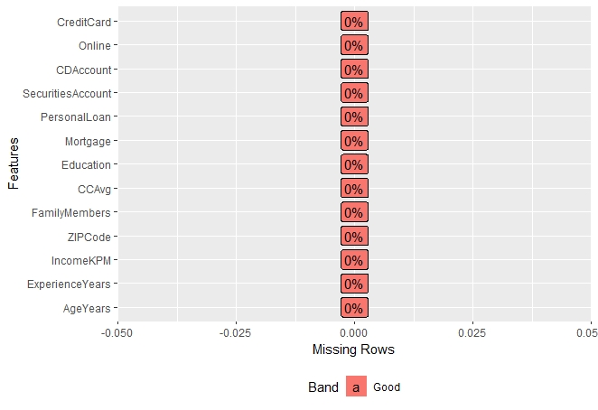

#Check Correlation between the independent variables

cormat=round(cor(TheraBank[c(1,2,3,4,5,6,7,8,10,11,12,13)],2)

cor.plot(cormat)

plot_correlation(TheraBank[c(1,2,3,4,5,6,7,8,10,11,12,13)])

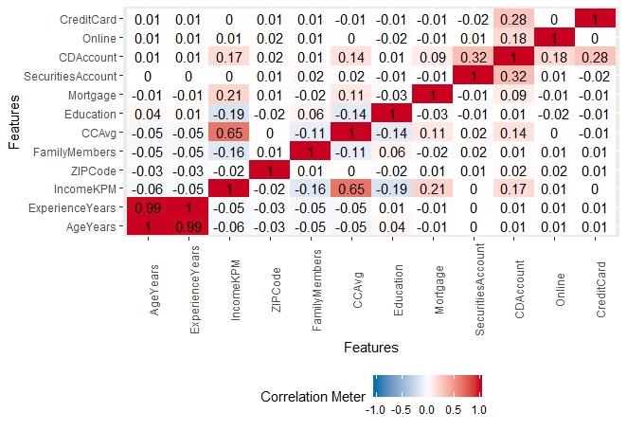

The above image indicates that the correlation between the independent variables is very low which is in favour of the model building.

plot_histogram(TheraBank)

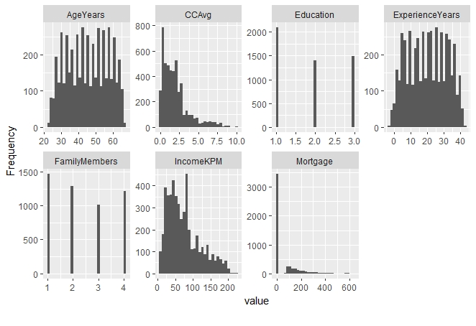

#Frequency distribution of categorical variable

table(TheraBank[,c(4)])

# Clustering & Interpretation

K-means clustering is the most commonly used unsupervised machine learning algorithm for partitioning a given dataset into a set of k groups (i.e. k clusters), where k represents the number of pre-specified groups. It classifies objects in multiple groups (i.e., clusters), such that objects within the same cluster are as similar as possible, whereas objects from different clusters are as dissimilar as possible (i.e., the variation between the groups is maximum and within the groups is minimum). In k-means clustering, each cluster is represented by its center (i.e, centroid) which corresponds to the mean of points assigned to the cluster.

K-means uses Euclidean distance to identify similar groups(whether a person will or will not respond).

names(TheraBank)

TheraClust <- TheraBank[-c(9)]

library(NbClust)

library(factoextra)

fviz_nbclust(TheraClust, kmeans, method = "wss")+

geom_vline(xintercept = 2, linetype = 2)+

labs(subtitle = "Elbow Method")

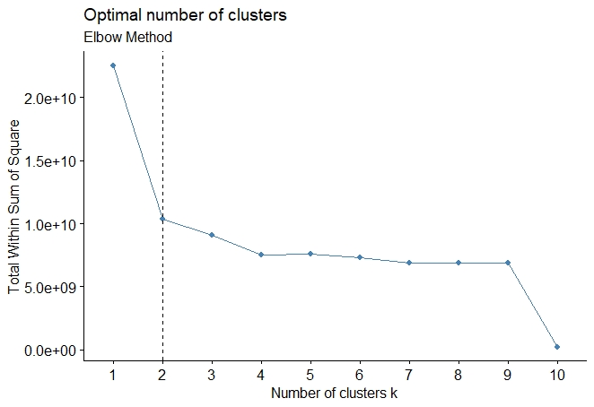

The elbow method will help determine the number of clusters to be selected for the dataset. Here, the above image indicates that “2” is the optimum number of clusters to be chosen.

#applying k-means cluster

kmeans.cluster = kmeans(TheraClust, 2)

kmeans.cluster$size

kmeans.cluster$cluster

kmeans.cluster$withinss

|  |  |
| --- | --- |
| Size | The number of points in each cluster. |
| Cluster | A vector of integers (from 1:k) indicating the cluster to which each point is allocated. |
| Withinss | Vector of within-cluster sum of squares, one component per cluster. |

#plotting the k-means

fviz_cluster(kmeans.cluster, data = TheraClust[-c(4)])

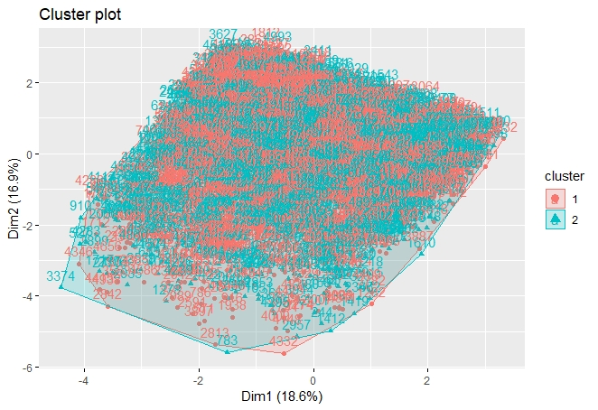

The above is a 2D graph represents observations that have been grouped into two clusters, where within group sum of square is minimum and between group sum of square is maximum. There are two centroids from which the Euclidean distance to each observation is calculated and grouped accordingly.

# Model Building & Interpretation

## CART Model

### Split the Data(70-30)

We will split the data and put 70% into the dataset- train and 30% into an unseen dataset- test. Splitting the data is done in order to test the model on an unseen dataset, that is built on the train dataset. This is done in order to evaluate if the model is an over-fit model or a best-fit model which can handle an unseen dataset. In case the model is an over-fitting model, the results will have a large variation.

library(caTools)

set.seed(100)

TheraBank_Split <- sample(1:nrow(TheraBank), 0.70*nrow(TheraBank))

CARTtrain <- TheraBank[TheraBank_Split,]

CARTtest <- TheraBank[-TheraBank_Split,]

dim(CARTtrain)

dim(CARTtest)

# Calculate the response rate

names(CARTtrain)

table(CARTtrain$PersonalLoan)

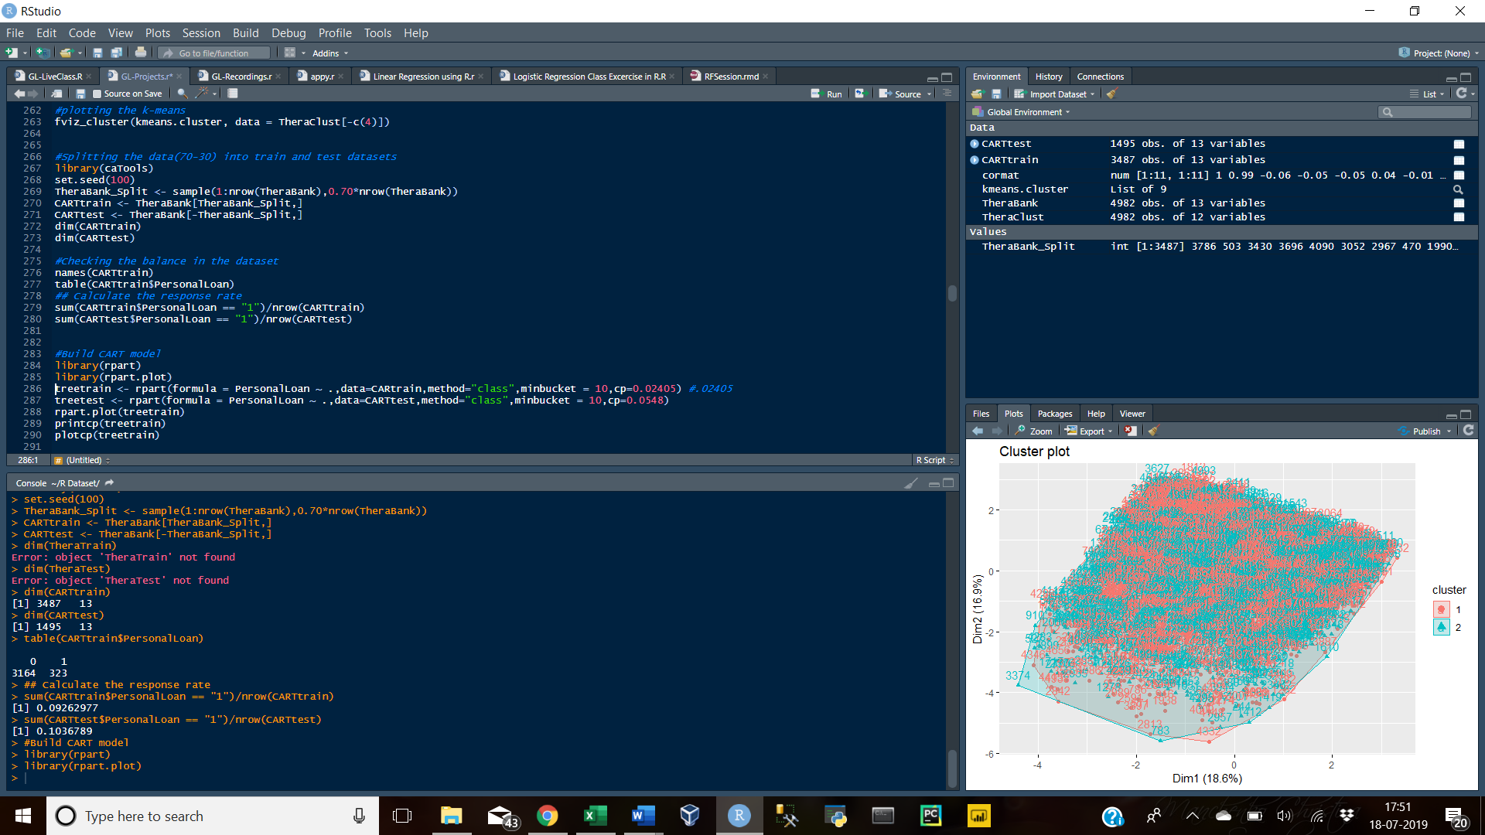

The result shows that the dataset is unbalance, where the count of “No” is more than the count of “Yes”.

sum(CARTtrain$PersonalLoan == "1")/nrow(CARTtrain)

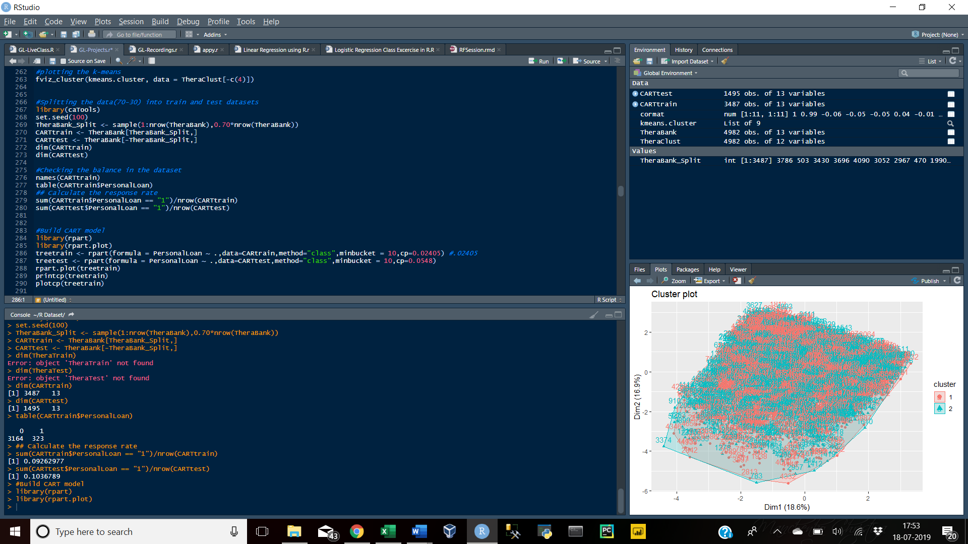

sum(CARTtest$PersonalLoan == "1")/nrow(CARTtest)

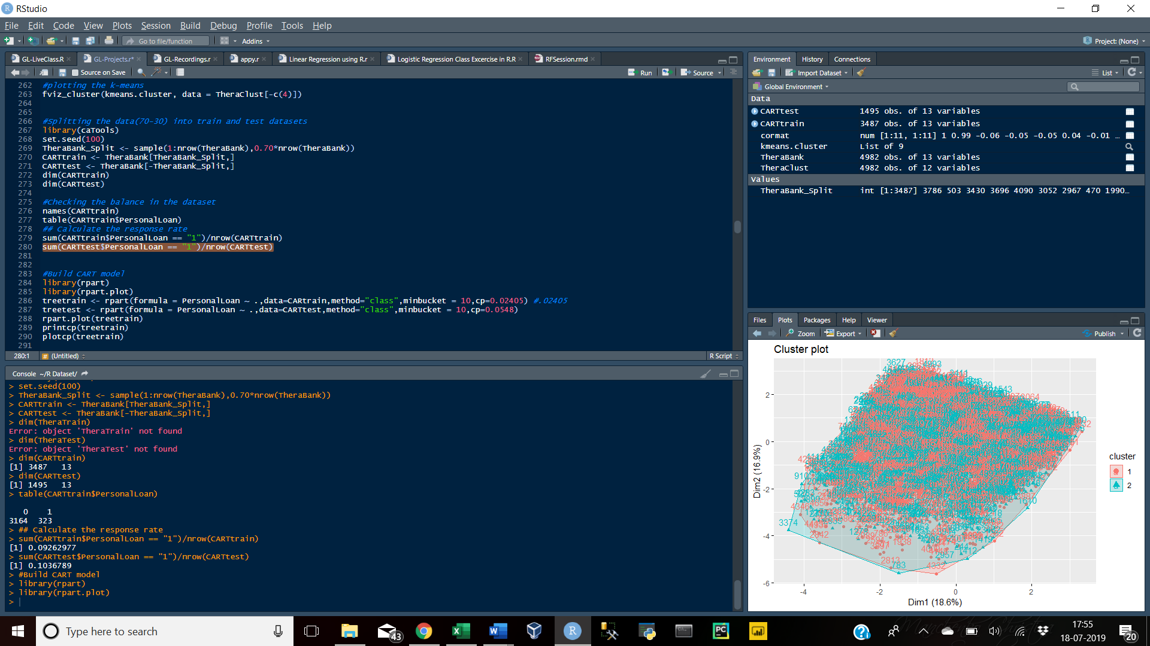

### Build the Model

While building the model, in order to select the best CP(complexity parameter) we will have to select the one with the lowest error rate(xerror).

|  |  |
| --- | --- |
| Parameters | Significance |
| control | a list of options that control details of the rpart algorithm. |
| xval | It will cross validate |
| CP(complexity parameter) | selecting the required size of tree |
| minsplit | the minimum number of observations that must exist in a node in order for a split to be attempted |
| minbucket | the minimum number of observations in any terminal node |

library(rpart)

library(rpart.plot)

treetrain <- rpart(formula = PersonalLoan ~ ., data = CARTtrain, method = "class", minbucket = 10, cp = 0)

rpart.plot(treetrain)

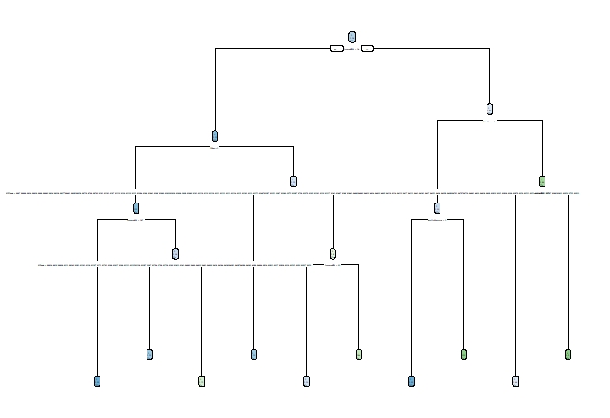

The above tree has too many leaves, which will lead to an over-fit model. Therefore, an optimum CP value needs to be selected in order to reduce the size of the tree. This process is called “pruning”.

printcp(treetrain)

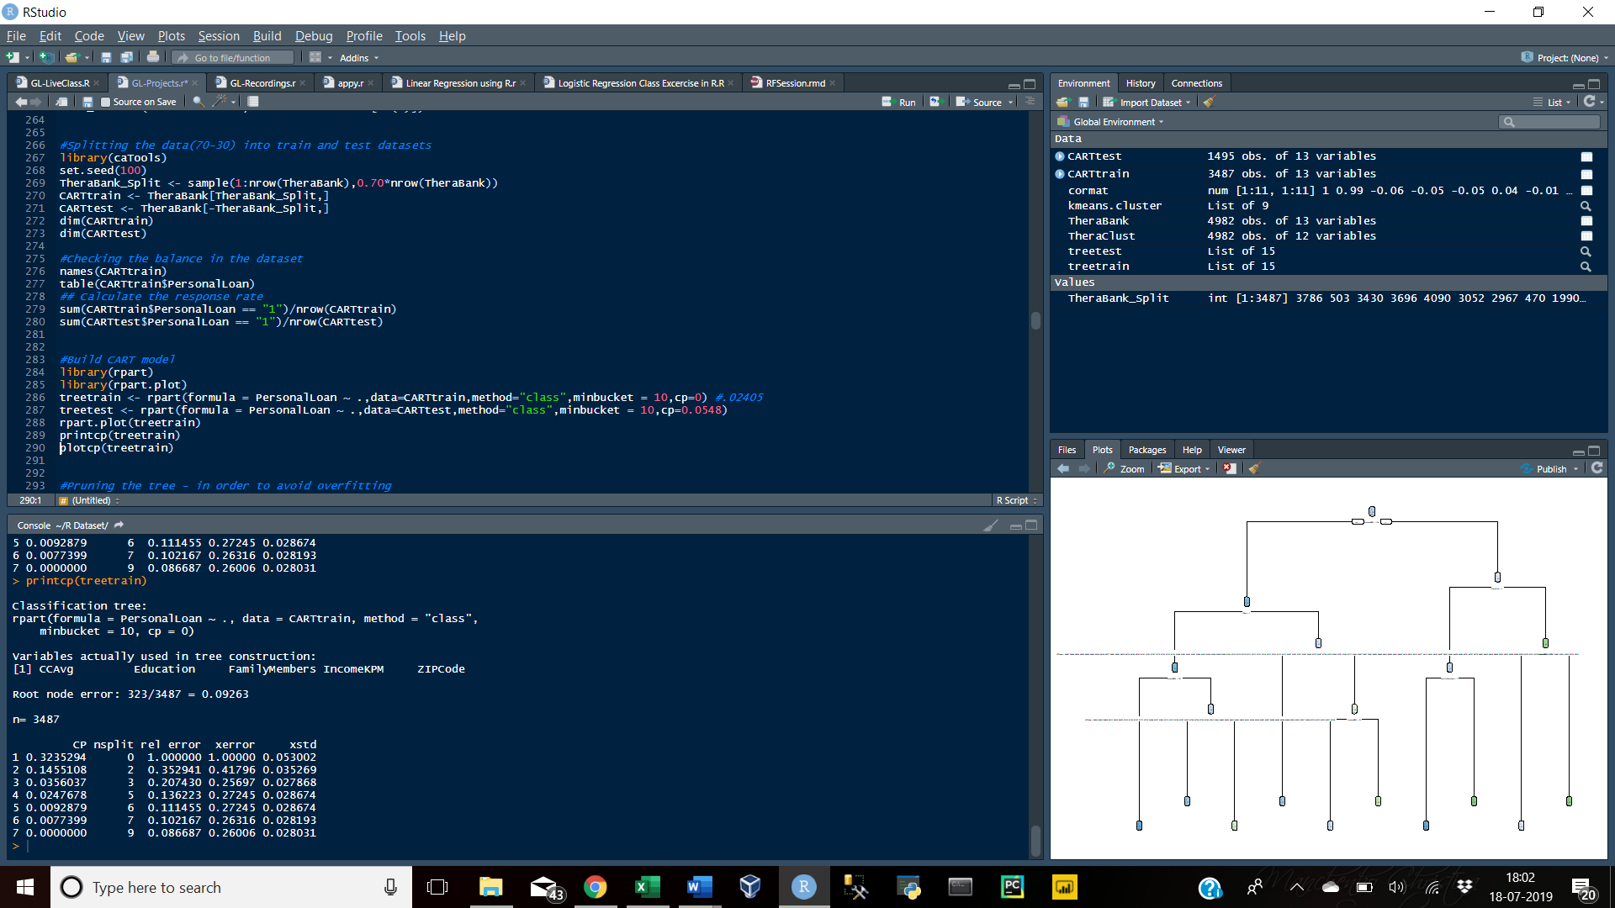

plotcp(treetrain)

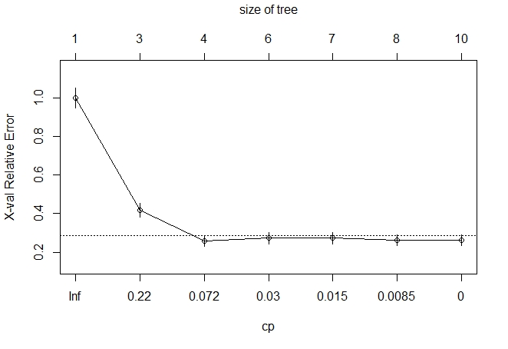

The above elbow plot indicates that either the CP value of tree with size 3 or 4 can be taken into consideration for the model building.

treetrain <- rpart(formula = PersonalLoan ~ ., data = CARTtrain,method = "class", minbucket = 10, cp = 0.03560)

rpart.plot(treetrain)

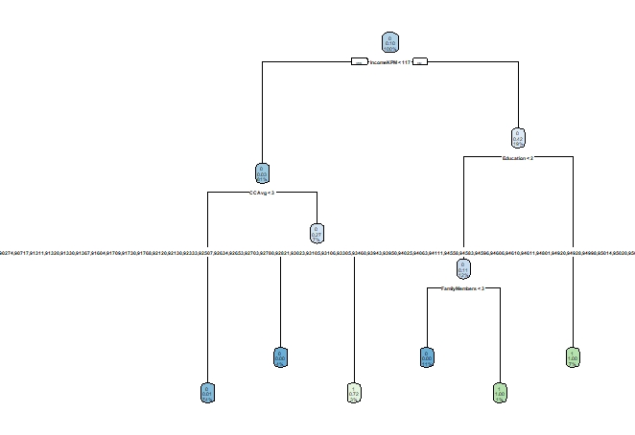

### Prune the Tree

ptreetrain <- prune(treetrain, cp = 0.03560,"CP")

ptreetest <- prune(treetest, cp = 0.0548,"CP")

#plot tree

rpart.plot(ptreetest)

##print cp value

printcp(ptreetest)

### Apply the Model

While applying the model and calculating the prediction on the basis of the score, the default threshold generally is 0.50, but here since the bank is looking for people who have lower chances of defaulting, a threshold value of 0.80 is selected. To bifurcate the people who are less likely to default from the ones who are more likely to default.

CARTtrain$CART.Pred = predict(ptreetrain,data=CARTtrain,type="class")

CARTtrain$CART.Score = predict(ptreetrain,data=CARTtrain,type="prob")[,"1"]

CARTtrain$CART.Pred=ifelse((CARTtrain$CART.Score>0.8),1,0)

View(CARTtrain)

CARTtest$CART.Pred = predict(ptreetest,CARTtest,type="class")

CARTtest$CART.Score = predict(ptreetest,CARTtest,type="prob")[,"1"]

CARTtest$CART.Pred=ifelse((CARTtest$CART.Score>0.8),1,0)

View(CARTtest)

table(TheraTrain$PersonalLoan)

3164/(3164+323)

## Build Random Forest model

### Split the Data(70-30)

library(randomForest)

set.seed(100)

TheraBank_Index <- sample(1:nrow(TheraBank),0.70*nrow(TheraBank))

RFtrain <- TheraBank[TheraBank_Index,]

RFtest <- TheraBank[-TheraBank_Index,]

#Select Optimum mtry Value –

The selection of mtry value should be such that it is neither too low and nor too high. If the mtry value is very low that the trees will be very weak and if the mtry is too high or equal to “M”(the number of variables) then the trees are bound to be highly correlated. Ideally the best mtry value is the square root of M.

Also, If the number of observations is large, but the number of trees is too small, then some observations will be predicted only once or even not at all. So to obtain the optimal number of trees(ntreetry), we can plot the OOB error rate(the mean prediction error) and select the point where it eventually starts to flatten. The value of ntreetry should be an odd number because random forest uses voting as a method for selection.

names(RFtrain)

x = RFtrain[, -c(9)]

y = RFtrain$PersonalLoan

bestmtry = tuneRF(x, y, stepFactor = 1.5, improve = 1e-5, ntreeTry =201)

#OR

bestmtry <- sqrt(13)

print(bestmtry)

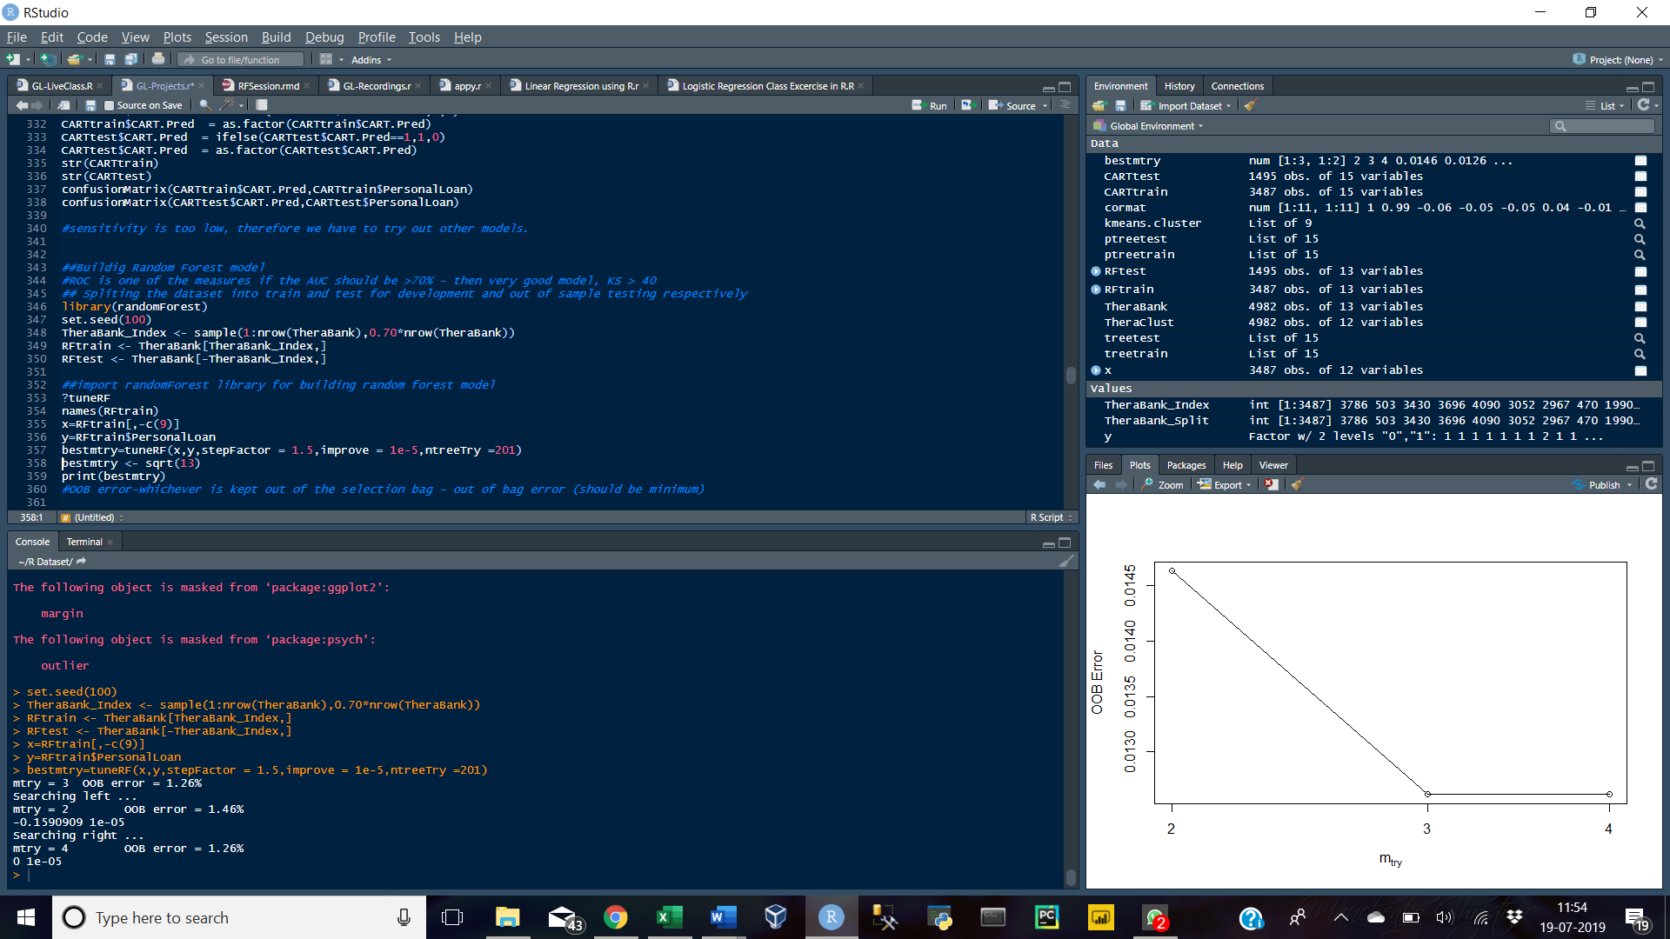

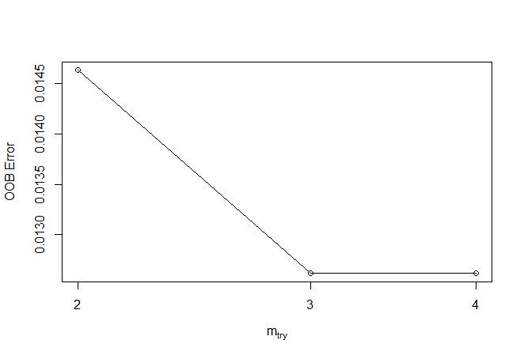

From the above results it is clear that an mtry value of 3 or 4 should be selected, where the OOB is the minimum.

### Build the Model

Rforest = randomForest(PersonalLoan~., data = RFtrain, ntree = 101, mtry = 4, nodesize = 10, importance = TRUE)

print(Rforest)

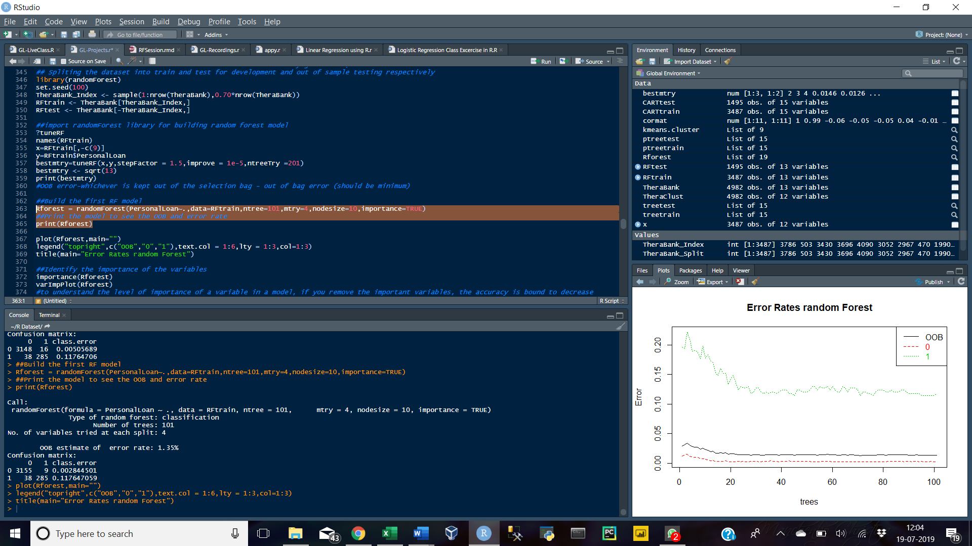

plot(Rforest,main="")

legend("topright", c("OOB", "0", "1"), text.col = 1:6, lty = 1:3,col=1:3)

title(main = "Error Rates random Forest")

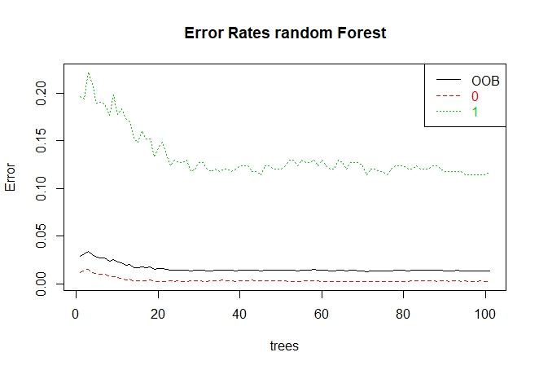

#Identify the importance of the variables –

To understand the level of importance of a variable in a model.

importance(Rforest)

varImpPlot(Rforest)

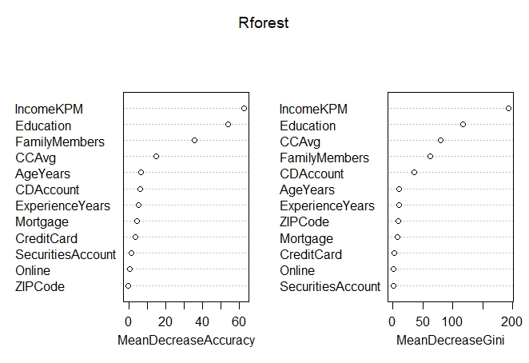

The above plot shows that the variables – IncomeKPM, Education, FamilyMembers, CCAvg are some of the most important variables considered in the model. If any of these variables are eliminated, it will have a high impact on the results(Accuracy and Gini Index) of the model.

### Tune the RF Model –

Tuning the Random Forest is important to obtain the optimum mtry, ntree values that affects the OOB error rate of the model.

|  |  |
| --- | --- |
| Parameters | Significance |
| x | matrix or data frame of predictor variables |
| y | response vector (factor for classification, numeric for regression) |
| mtryStart | starting value of mtry |
| ntreeTry | number of trees used at the tuning step |
| stepFactor | at each iteration, mtry is inflated (or deflated) by this value |
| improve | the (relative) improvement in OOB error must be by this much for the search to continue |
| trace | whether to print the progress of the search |
| plot | whether to plot the OOB error as function of mtry |
| doBest | whether to run a forest using the optimal mtry found |
| nodesize | minimal number of records in a node in order for a split to be performed |
| importance | extract variable importance measures |

set.seed(1000)

tRforest = tuneRF(x = RFtrain[,-c(9)], y = RFtrain$PersonalLoan,mtrystart = 3, stepfactor = 1.5, ntree = 101, improve=0.0001, nodesize =10, trace=TRUE, plot = TRUE, doBest = TRUE, importance = TRUE)

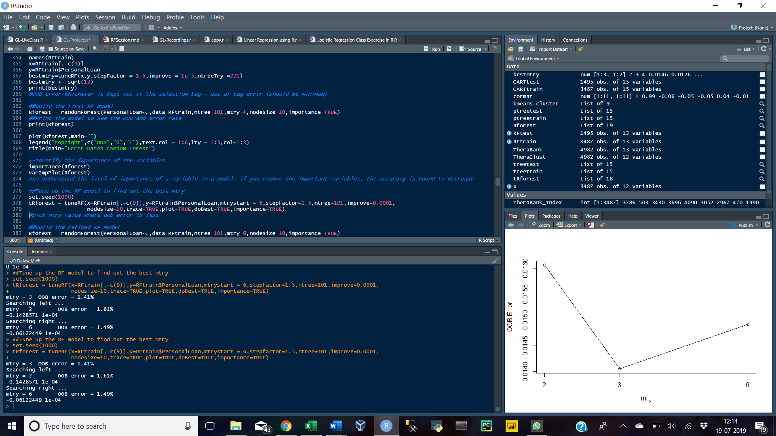

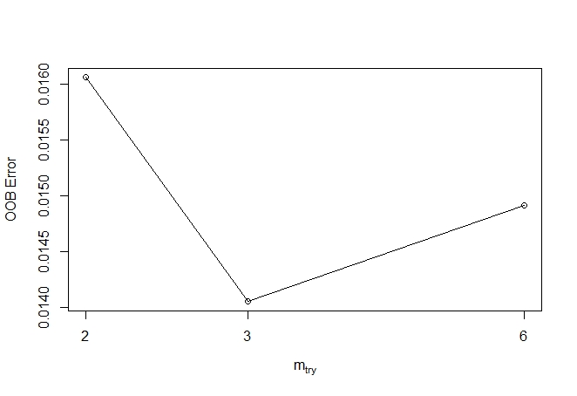

### Build the Refined RF Model

Rforest = randomForest(PersonalLoan~.,data = RFtrain, ntree = 101, mtry = 4, nodesize = 10, importance = TRUE)

print(Rforest)

plot(Rforest)

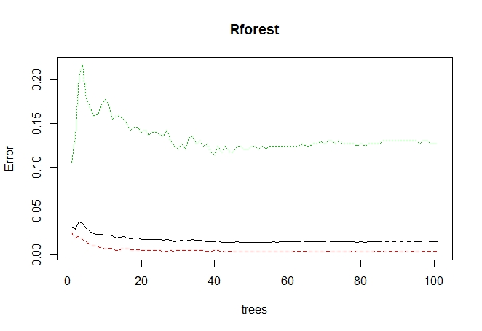

### Apply the Model

RFtrain$RF.Pred = predict(Rforest, data = RFtrain, type = "class")

RFtrain$RF.Score = predict(Rforest,data = RFtrain, type="prob")[,"1"]

RFtrain$RF.Pred = ifelse((RFtrain$RF.Score>0.8),1,0)

View(RFtrain)

RFtest$RF.Pred = predict(Rforest,RFtest, type="class")

RFtest$RF.Score = predict(Rforest, RFtest,type="prob")[,"1"]

RFtest$RF.Pred = ifelse((RFtest$RF. Score>0.8),1,0)

table(RFtrain$RF.Pred,RFtrain$PersonalLoan)

#Confusion Matrix

RFtrain$RF.Pred = ifelse(RFtrain$RF.Pred==1,1,0)

RFtrain$RF.Pred = as.factor(RFtrain$RF.Pred)

RFtest$RF.Pred = ifelse(RFtest$RF.Pred==1,1,0)

RFtest$RF.Pred = as.factor(RFtest$RF.Pred)

confusionMatrix(RFtrain$RF.Pred,RFtrain$PersonalLoan)

confusionMatrix(RFtest$RF.Pred,RFtest$PersonalLoan)

# Model Performance Check

|  |  |
| --- | --- |
| Model Evaluation Metrices | |
| AUC-ROC Curve | The ROC curve is the plot between sensitivity(True Positive rate) and 1- specificity(False Positive Rate). |
| Confusion Matrix | A confusion matrix is an N X N matrix, where N is the number of classes being predicted. |
| KS | K-S or Kolmogorov-Smirnov chart is a measure of the degree of separation between the positive and negative distributions. |
| Concordance | the concordant pair is where the probability of responder is higher than non-responder. Whereas discordant pair is where the vice-versa holds true. |
| Gini Coefficient | Gini is nothing but ratio between area between the ROC curve and the diagonal line & the area of the above triangle(2*AUC – 1). |

library(ROCR)

library(ineq)

library(InformationValue)

## Confusion Matrix

CART

CART_CM_train = table(CARTtrain$PersonalLoan,CARTtrain$CART.Pred)

CART_CM_test = table(CARTtest$PersonalLoan,CARTtest$CART.Pred)

CART_CM_train

CART_CM_test

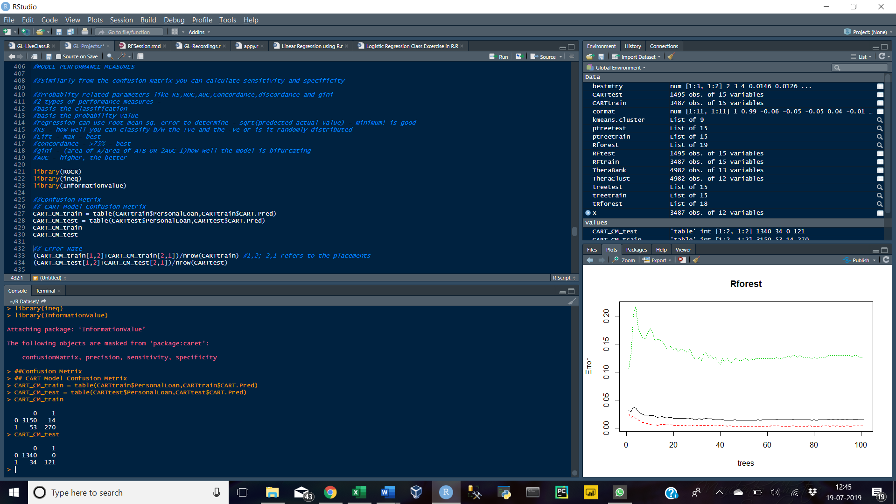

RF Model

RF_CM_train = table(RFtrain$PersonalLoan,RFtrain$RF.Pred)

RF_CM_test = table(RFtest$PersonalLoan,RFtest$RF.Pred)

RF_CM_train

RF_CM_test

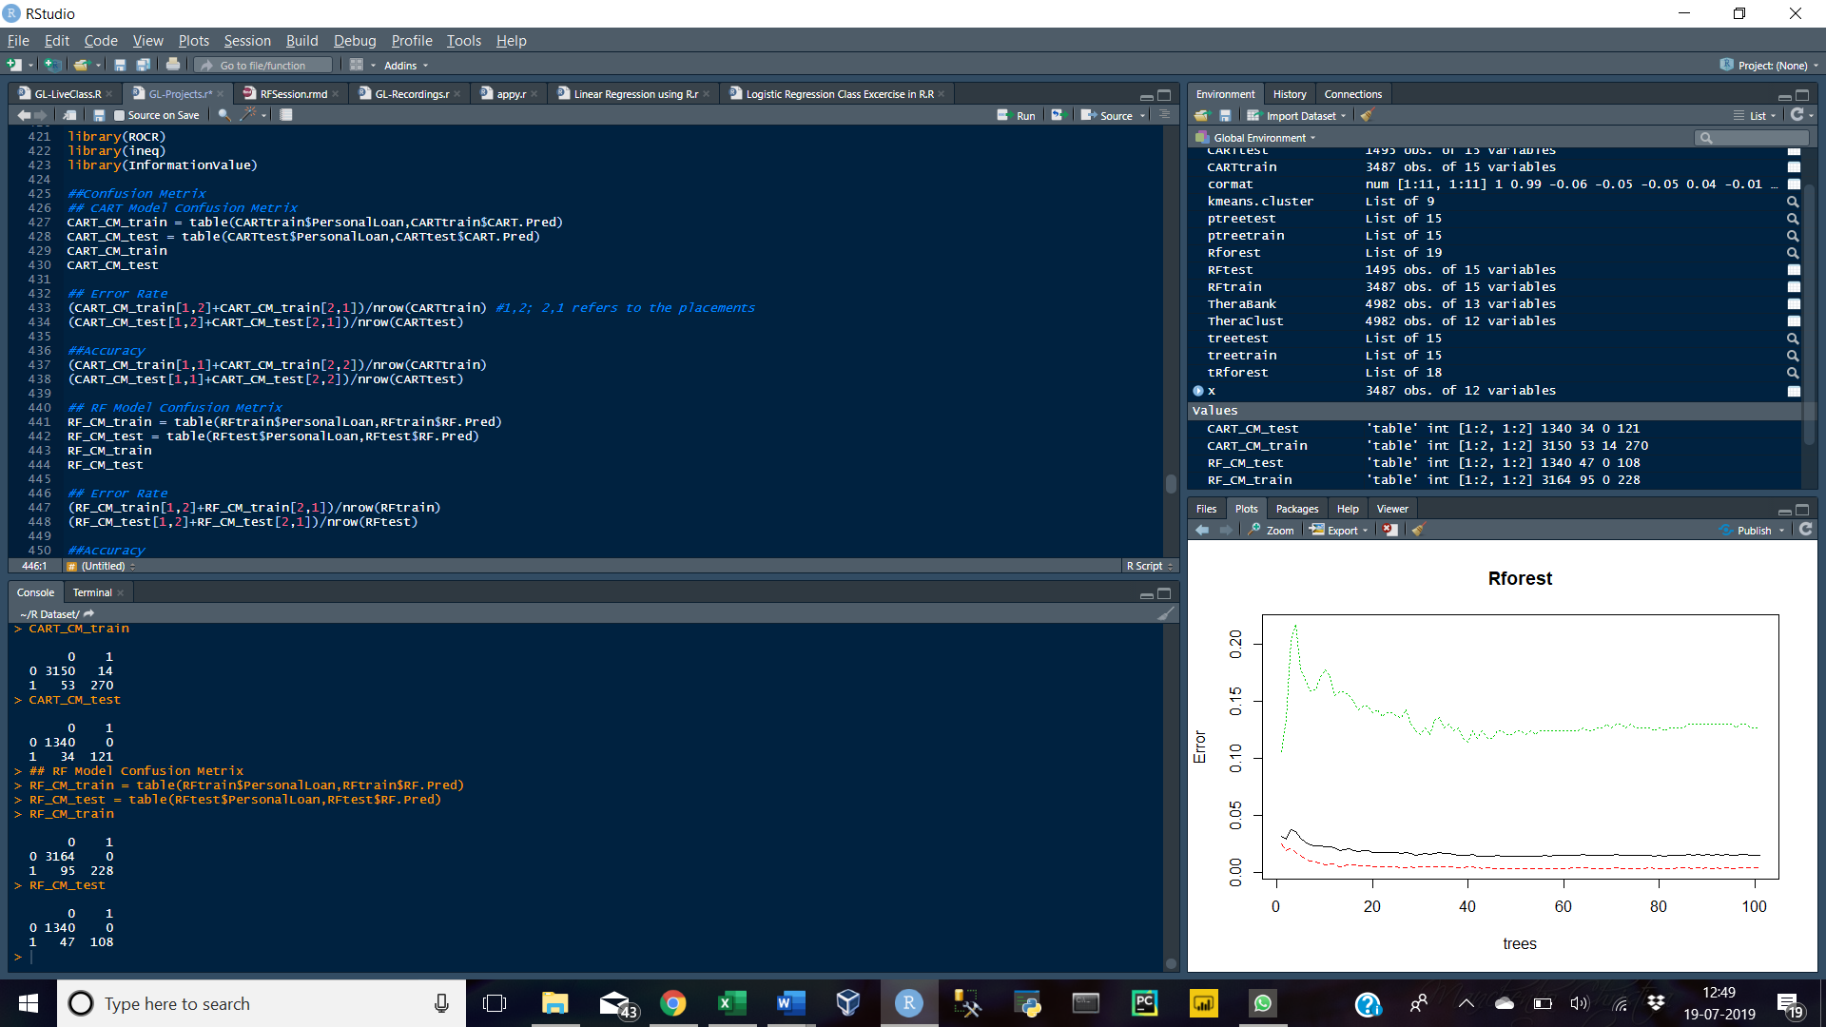

## Error Rate

CART

(CART_CM_train[1,2]+CART_CM_train[2,1])/nrow(CARTtrain) #1,2; 2,1 refers to the placements

(CART_CM_test[1,2]+CART_CM_test[2,1])/nrow(CARTtest)

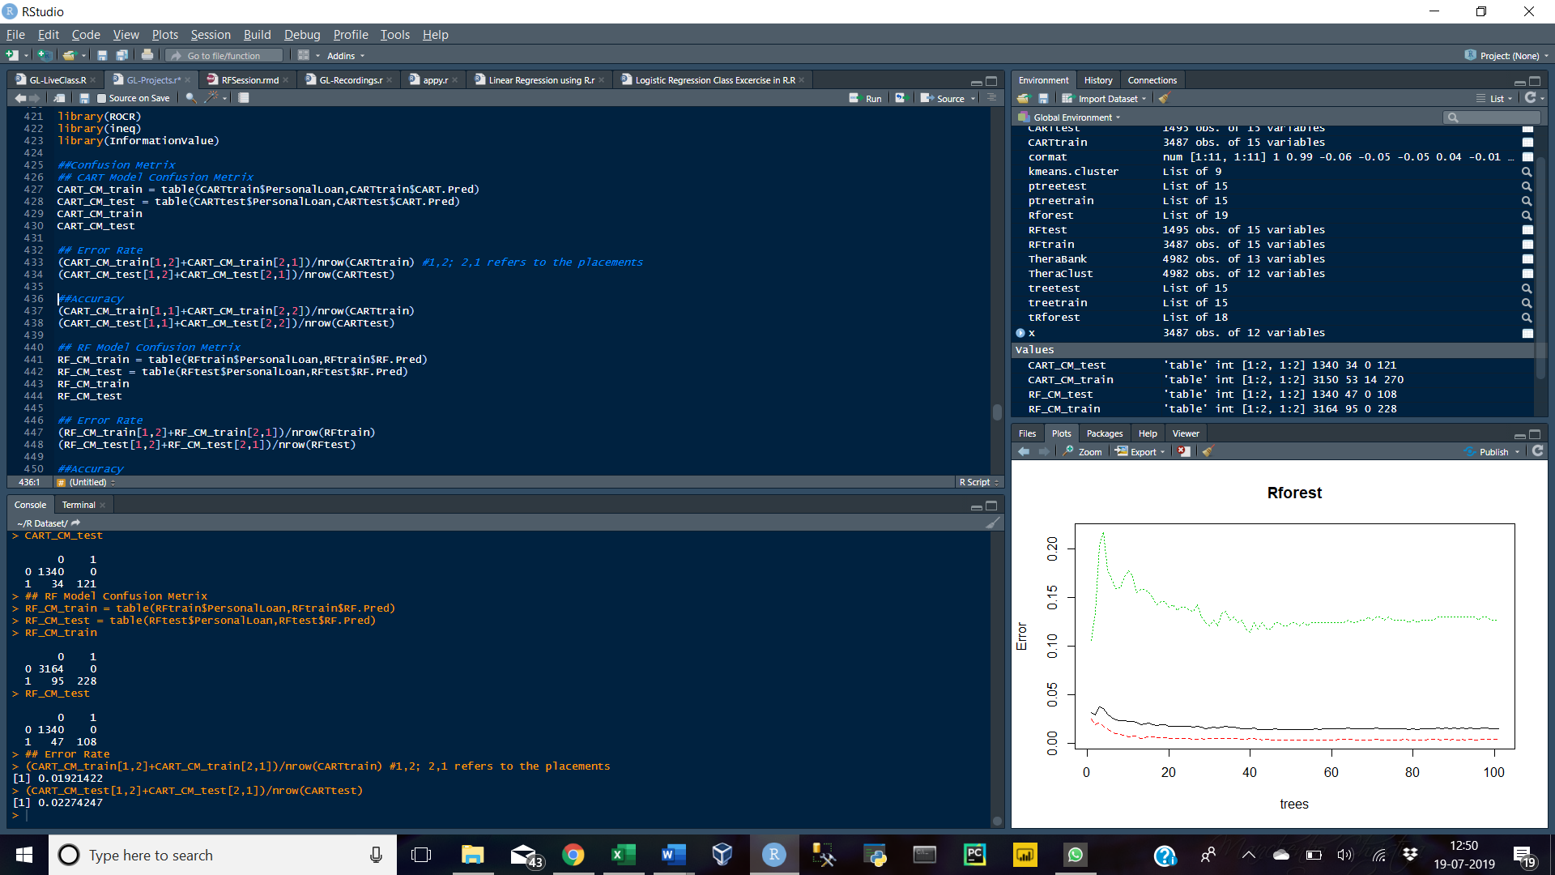

RF Model

(RF_CM_train[1,2]+RF_CM_train[2,1])/nrow(RFtrain)

(RF_CM_test[1,2]+RF_CM_test[2,1])/nrow(RFtest)

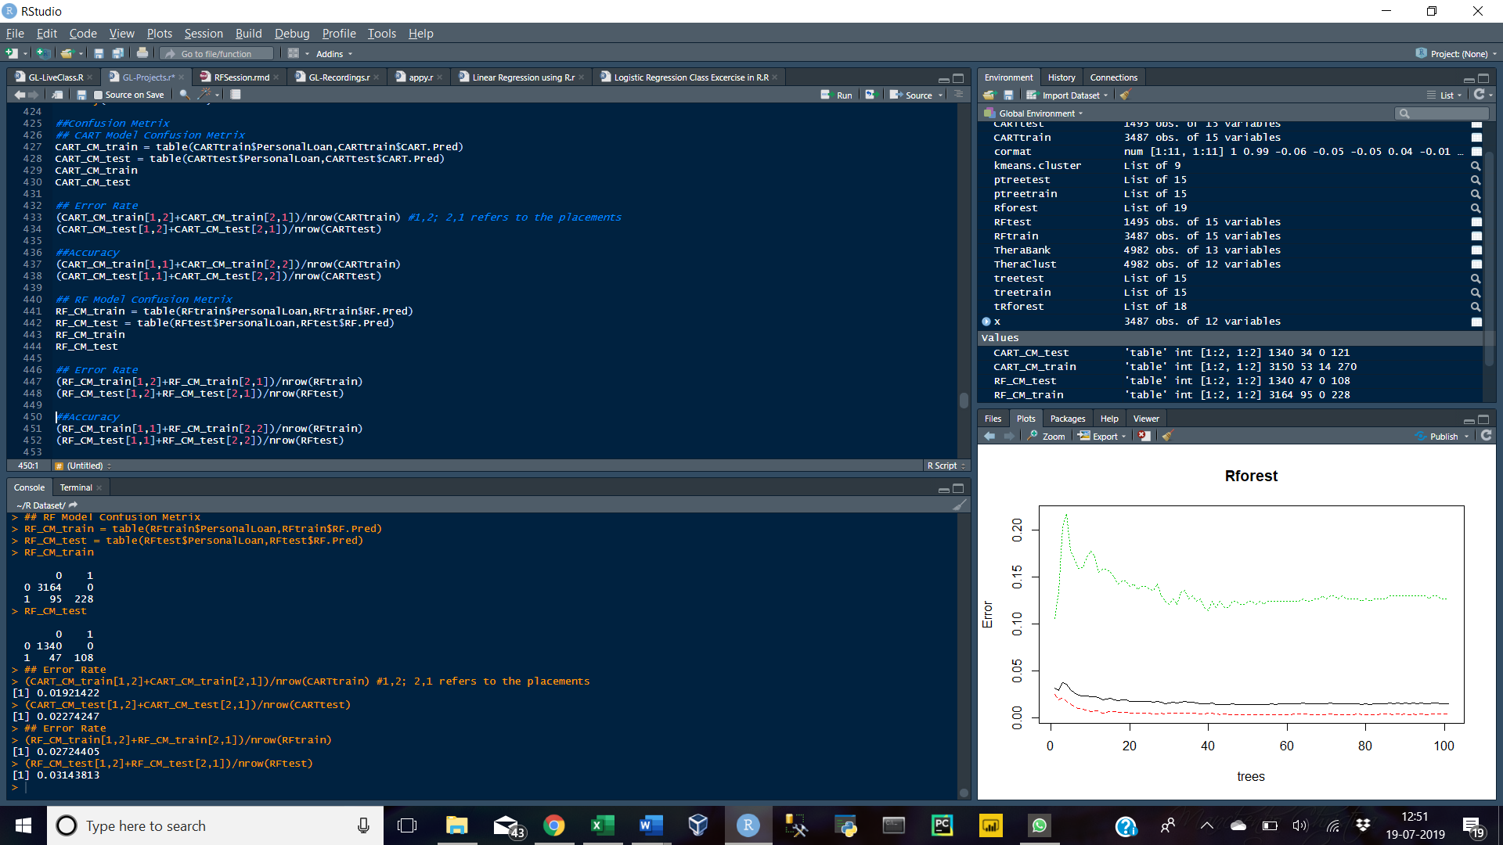

## Accuracy

CART

(CART_CM_train[1,1]+CART_CM_train[2,2])/nrow(CARTtrain)

(CART_CM_test[1,1]+CART_CM_test[2,2])/nrow(CARTtest)

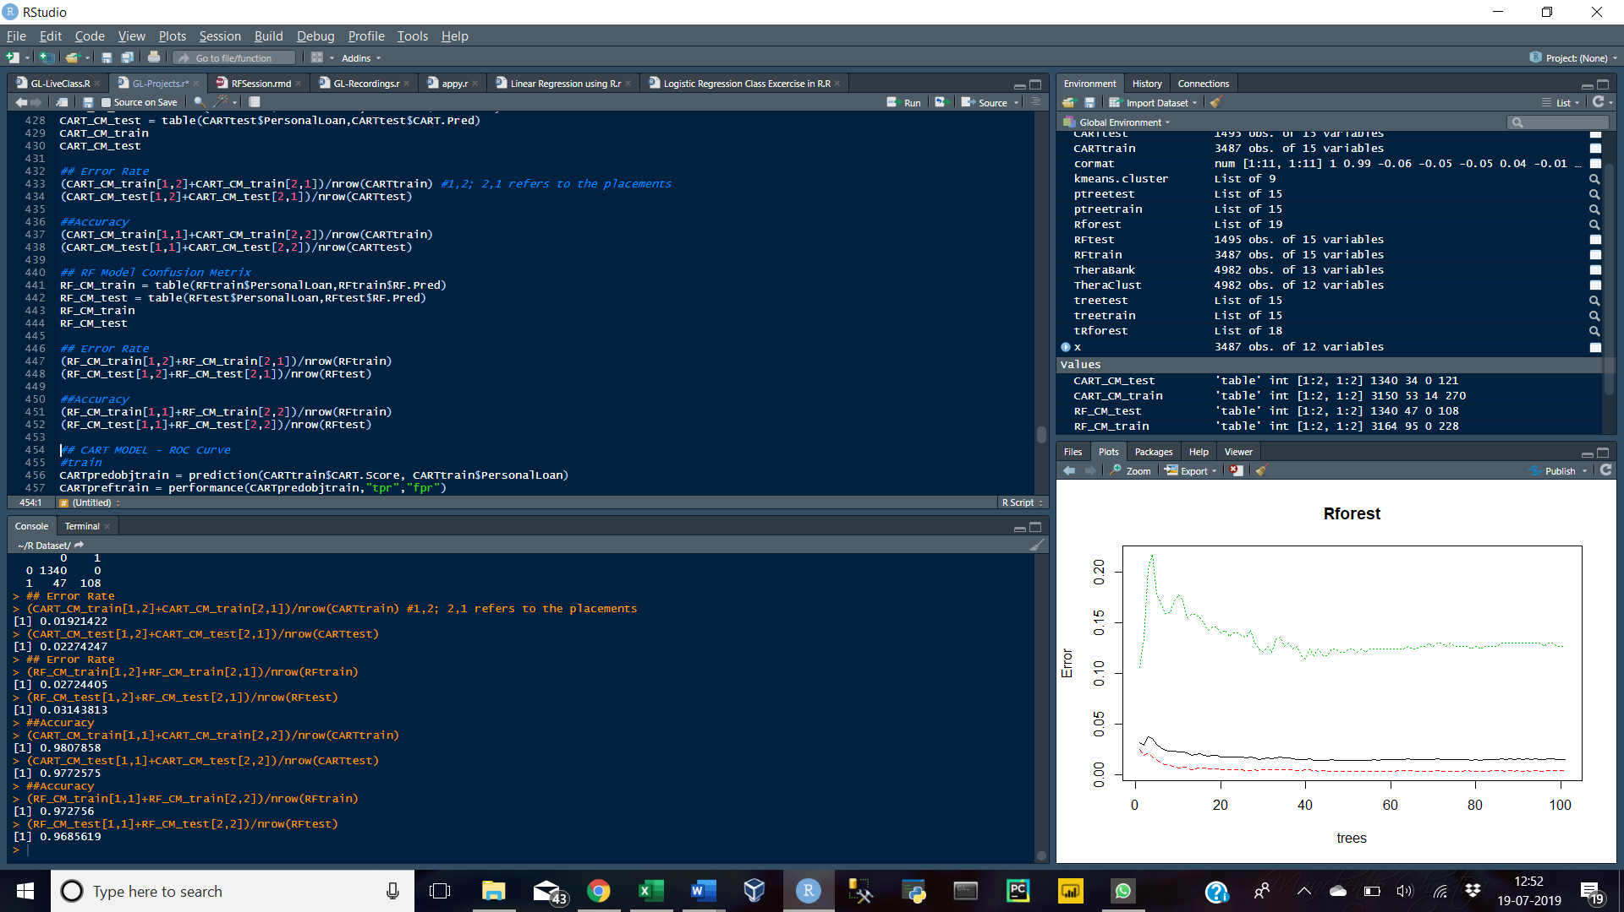

RF Model

(RF_CM_train[1,1]+RF_CM_train[2,2])/nrow(RFtrain)

(RF_CM_test[1,1]+RF_CM_test[2,2])/nrow(RFtest)



## ROC Curve

CART – train

CARTpredobjtrain = prediction(CARTtrain$CART.Score, CARTtrain$PersonalLoan)

CARTpreftrain = performance(CARTpredobjtrain,"tpr","fpr")

plot(CARTpreftrain)

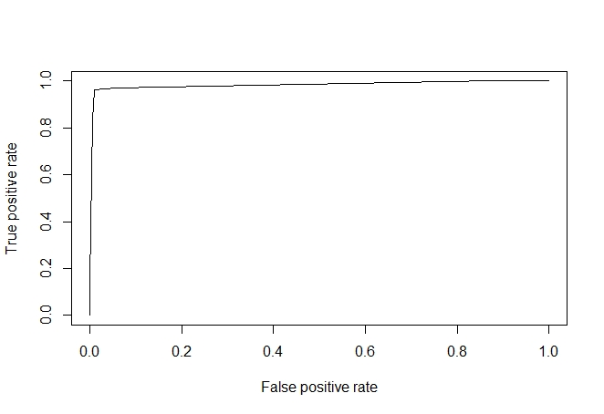

CART – test

CARTpredobjtest = prediction(CARTtest$CART.Score, CARTtest$PersonalLoan)

CARTpreftest = performance(CARTpredobjtest,"tpr","fpr")

plot(CARTpreftest)

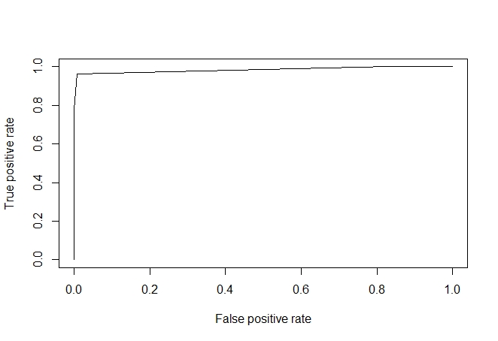

RF - train

RFpredobjtrain = prediction(RFtrain$RF.Score,RFtrain$PersonalLoan)

RFpreftrain = performance(RFpredobjtrain,"tpr","fpr")

plot(RFpreftrain)

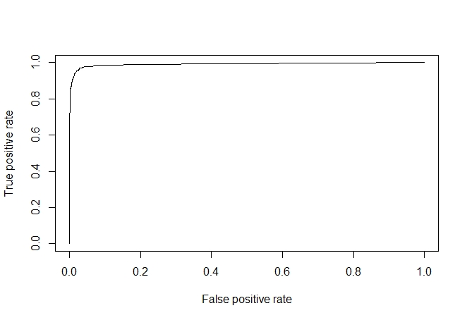

RF - test

RFpredobjtest = prediction(RFtest$RF.Score,RFtest$PersonalLoan)

RFpreftest = performance(RFpredobjtest,"tpr","fpr")

plot(RFpreftest)

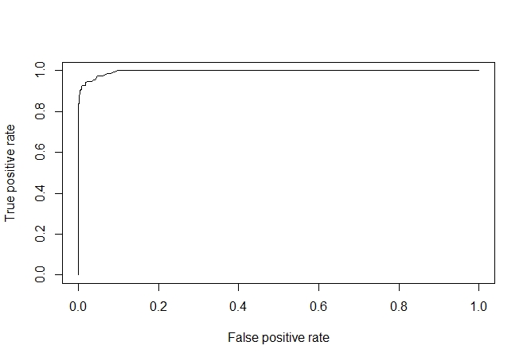

## KS

CART

max(CARTpreftrain@y.values[[1]]-CARTpreftrain@x.values[[1]])

max(CARTpreftest@y.values[[1]]-CARTpreftest@x.values[[1]])

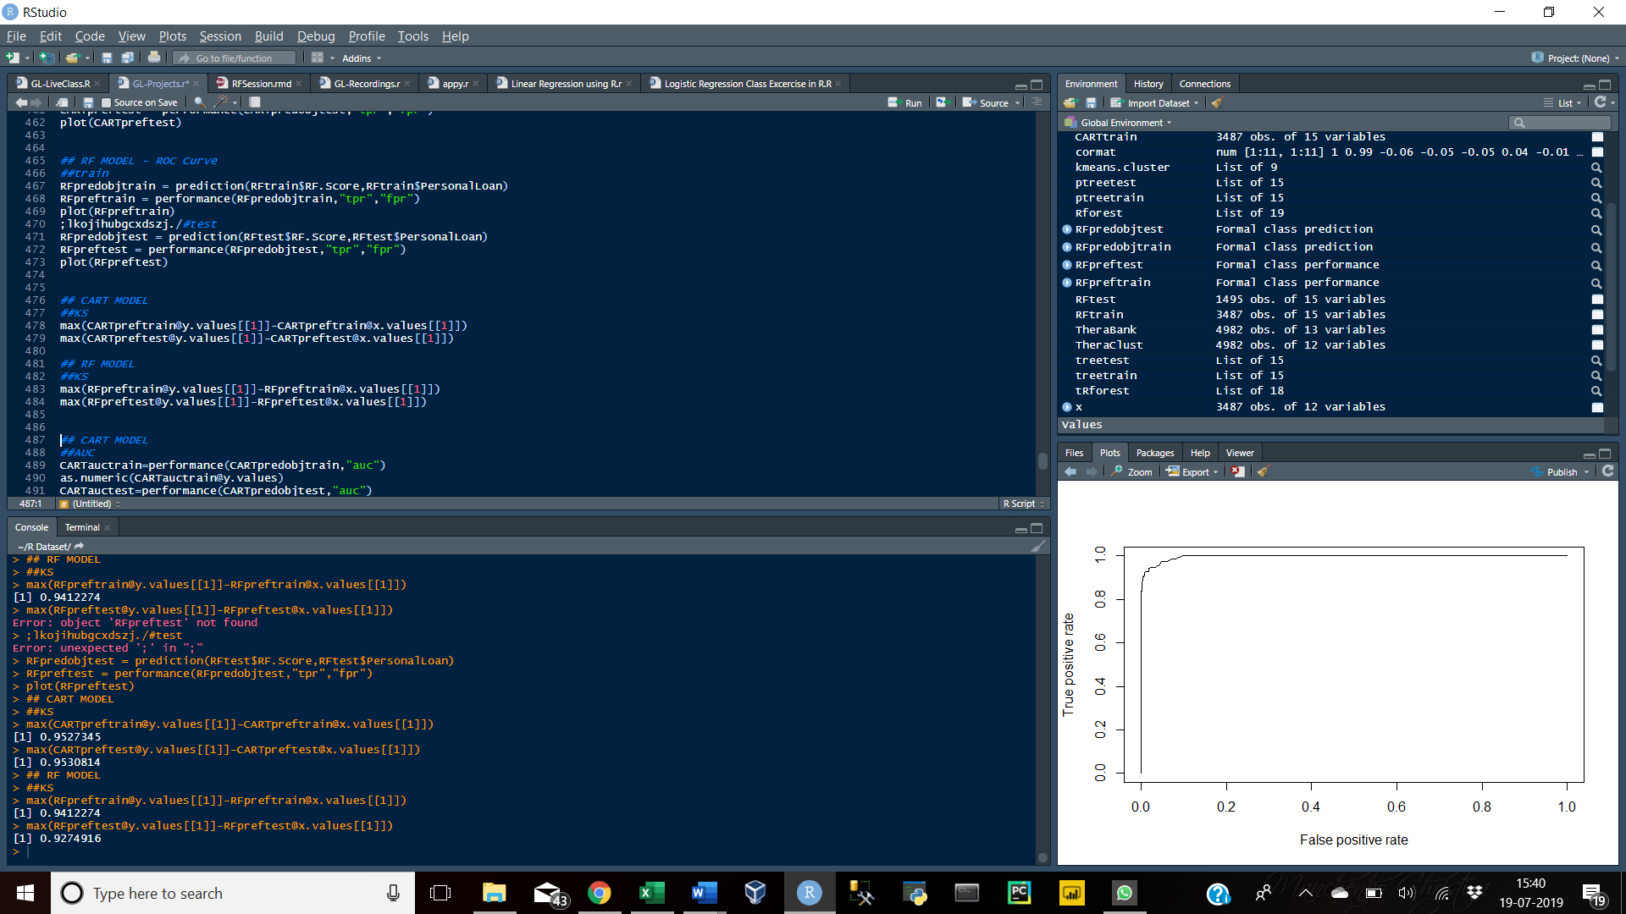

RF

max(RFpreftrain@y.values[[1]]-RFpreftrain@x.values[[1]])

max(RFpreftest@y.values[[1]]-RFpreftest@x.values[[1]])



## AUC

CART

CARTauctrain=performance(CARTpredobjtrain,"auc")

as.numeric(CARTauctrain@y.values)

CARTauctest=performance(CARTpredobjtest,"auc")

as.numeric(CARTauctest@y.values)

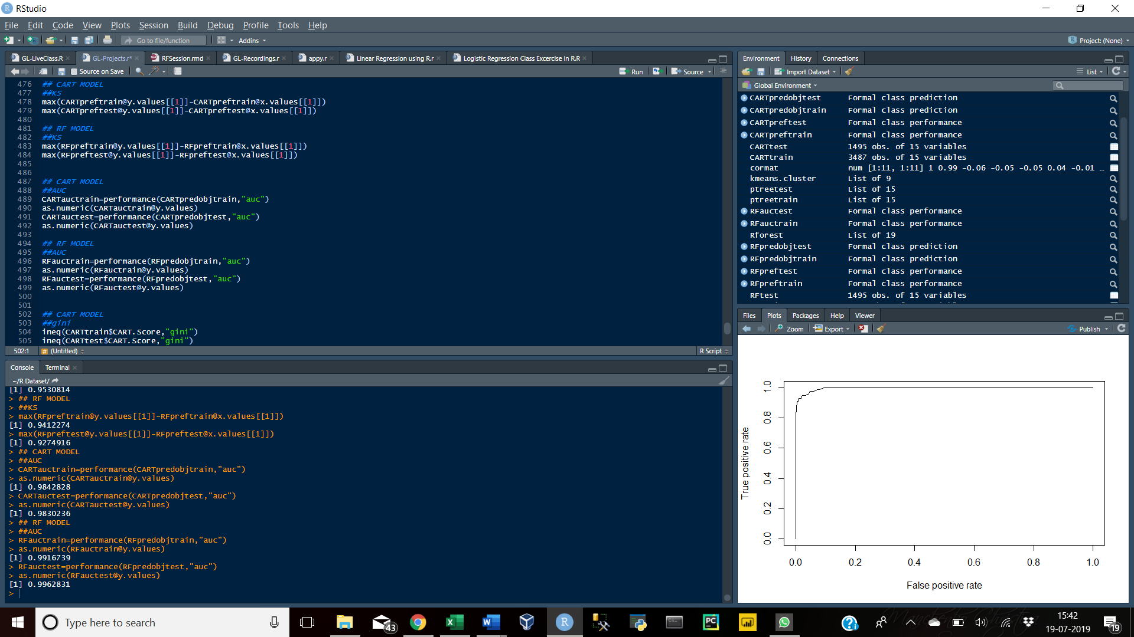

RF

RFauctrain=performance(RFpredobjtrain,"auc")

as.numeric(RFauctrain@y.values)

RFauctest=performance(RFpredobjtest,"auc")

as.numeric(RFauctest@y.values)



## GINI

CART

ineq(CARTtrain$CART.Score,"gini")

ineq(CARTtest$CART.Score,"gini")

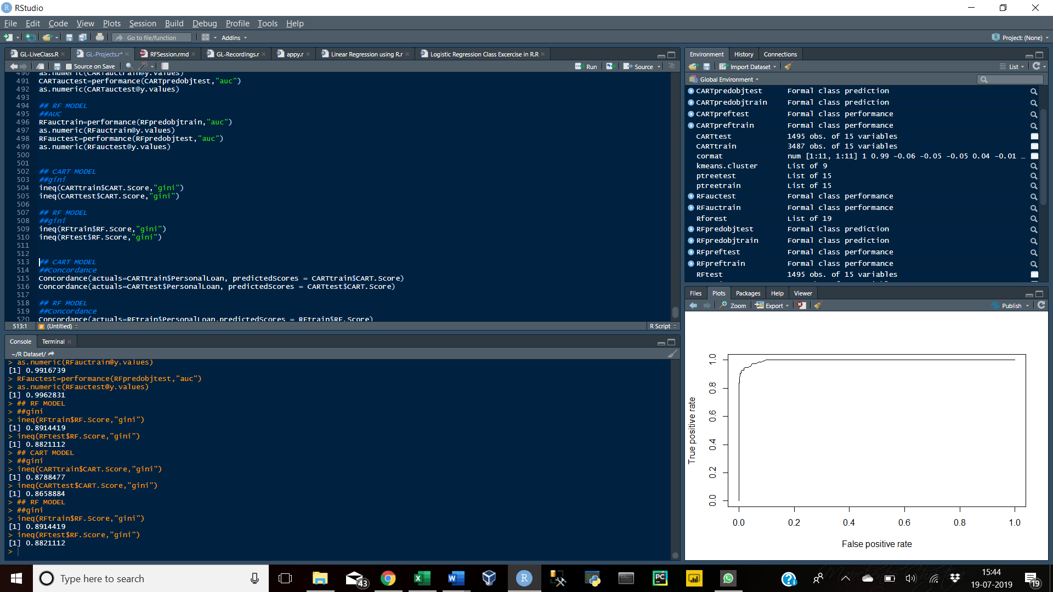

RF

ineq(RFtrain$RF.Score,"gini")

ineq(RFtest$RF.Score,"gini")



## Concordance

CART

Concordance(actuals=CARTtrain$PersonalLoan, predictedScores = CARTtrain$CART.Score)

Concordance(actuals=CARTtest$PersonalLoan, predictedScores = CARTtest$CART.Score)

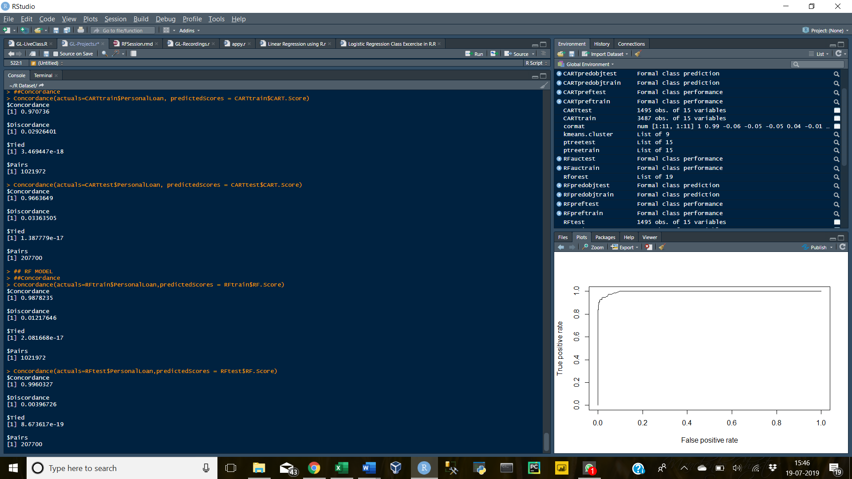

RF

Concordance(actuals=RFtrain$PersonalLoan,predictedScores = RFtrain$RF.Score)

Concordance(actuals=RFtest$PersonalLoan,predictedScores = RFtest$RF.Score)



# Conclusion

|  |  |  |  |  |  |  |  |  |  |  |  |  |
| --- | --- | --- | --- | --- | --- | --- | --- | --- | --- | --- | --- | --- |
|  | GINI | | Error Rate | | Accuracy | | KS | | AUC | | Concordance | |
|  | CART | RF | CART | RF | CART | RF | CART | RF | CART | RF | CART | RF |
| Train | 0.879 | 0.891 | 0.019 | 0.027 | 0.981 | 0.973 | 0.953 | 0.941 | 0.984 | 0.992 | 0.971 | 0.988 |
| Test | 0.866 | 0.882 | 0.023 | 0.031 | 0.977 | 0.969 | 0.953 | 0.927 | 0.983 | 0.996 | 0.966 | 0.996 |

From the above table it is clear that there is some difference in the results of the two models.

We will therefore select the model with a lower Error Rate i.e. the CART model. The CART model has an error rate of 1.9% whereas the Random Forest Model has 2.7% as the error rate.

# Source of Data

* Great Learning Mentored Learning Session - Model Performance Measures
* Google
* R Blogger
* stats.stackexchange.com
* uc-r.github.io